DEREK AND THE SLAMMERS
THE ULTIMATE VARIETY BAND
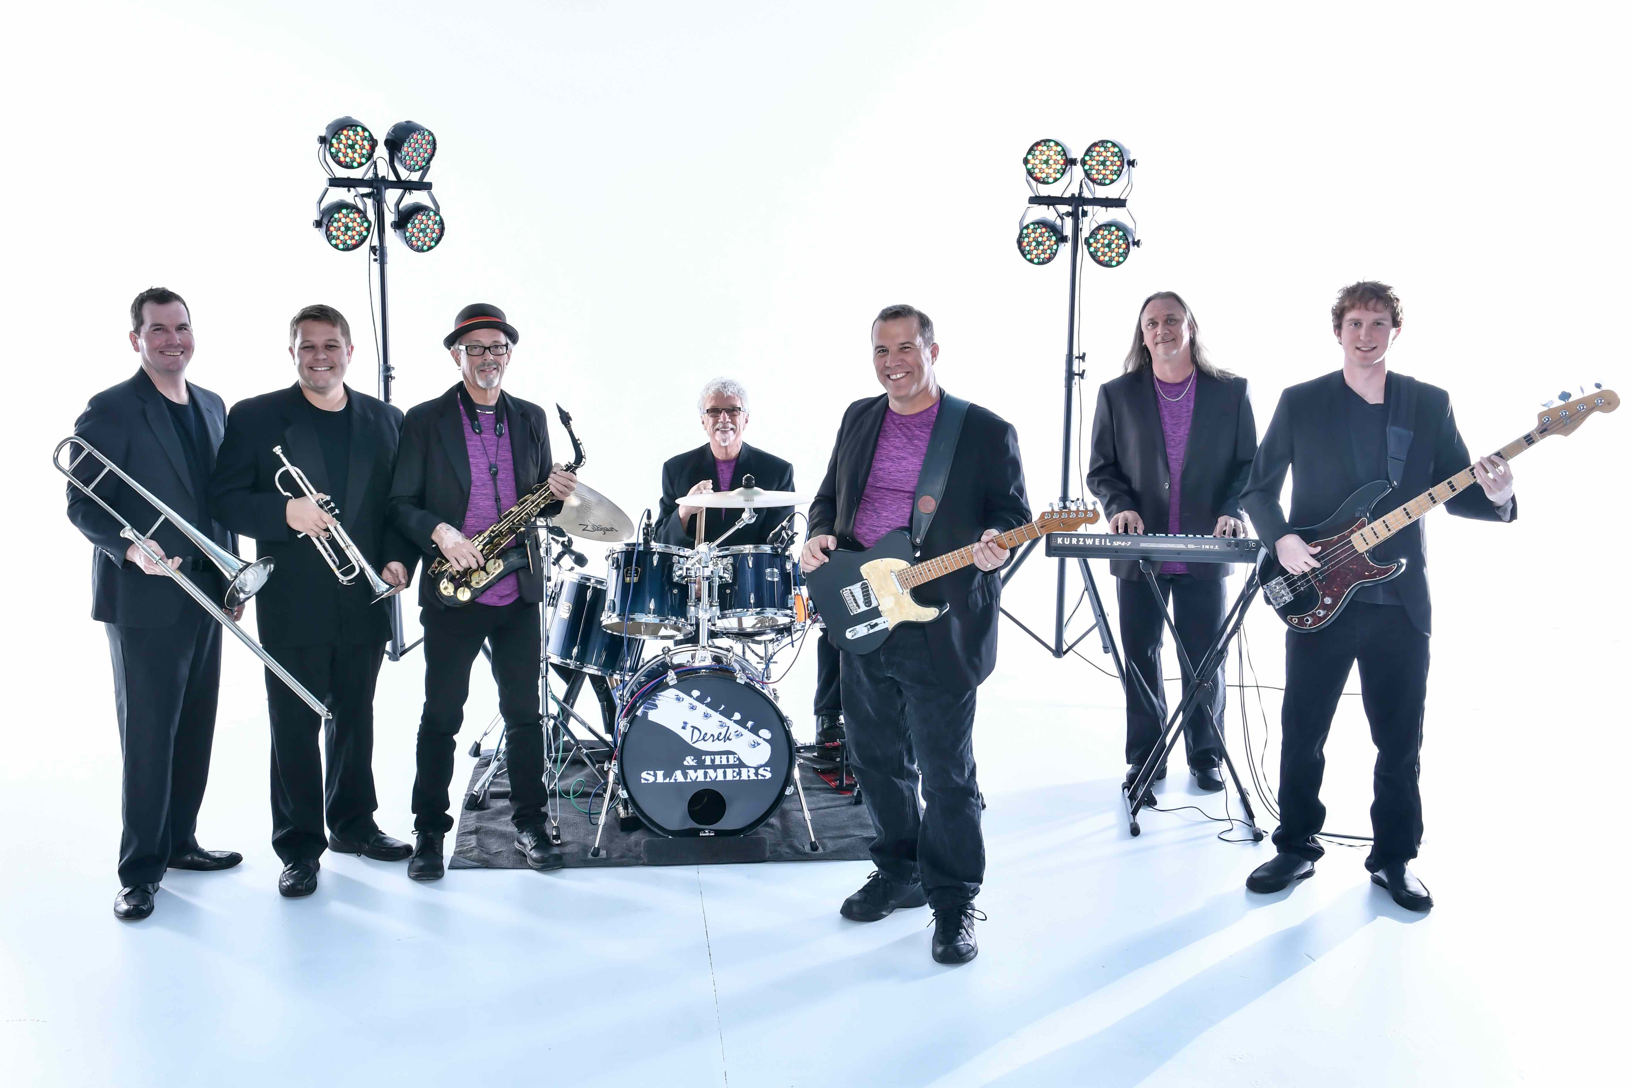

Derek and the Slammers is the ultimate variety band with a versatile song list that can fit into any theme. Whether your guests want to hear 50’s Doo Wop, the eclectic decade of the 60’s, the Disco 70’s, the Classic Rock 80’s, Tropical, Country, Reggae, Swing, or just about anything else, Derek & The Slammers can provide the perfect entertainment for your big bash. This versatile group can come as a trio to a full 9 pc band with horns, and have performed for many satisfied clients including: Toyota, Coca-Cola, Walt Disney World, Hard Rock Café, House of Blues, World Cup Soccer, Orlando Magic, AT&T, Microsoft, McDonald’s Australia, and many more.

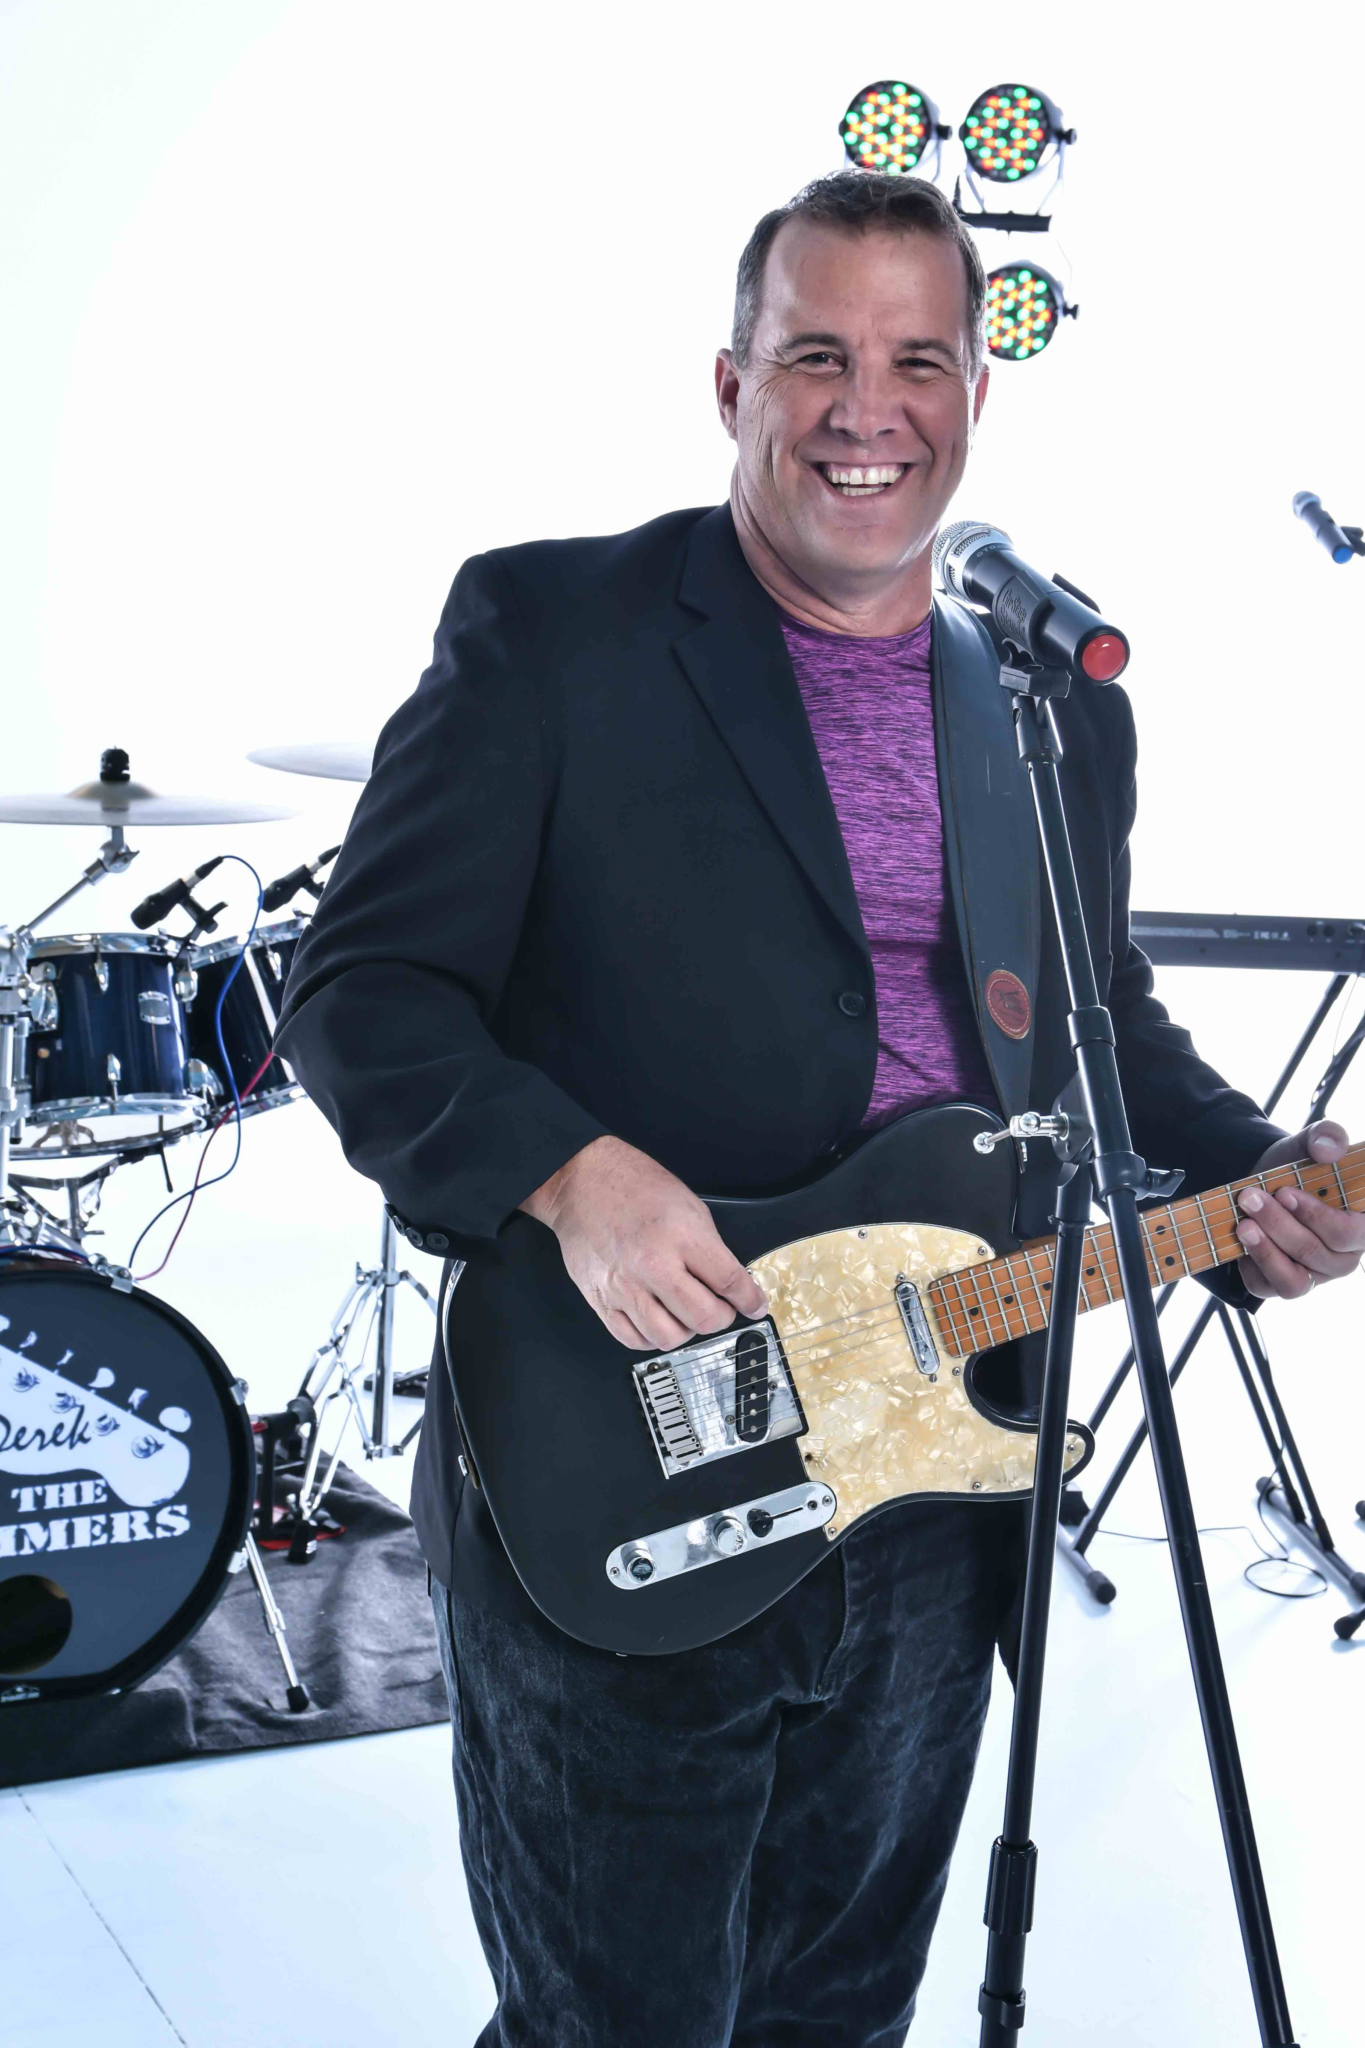
BAND OPTIONS:

SOLO

For social functions, cocktail receptions, pool parties, or whatever your event requires, Derek will perform any kind of music that will fit your theme. Derek comes fully self-contained with sound system, guitar, and a repertoire of hundreds of songs. He'll even take requests!

TRIO, QUARTET, ETC.
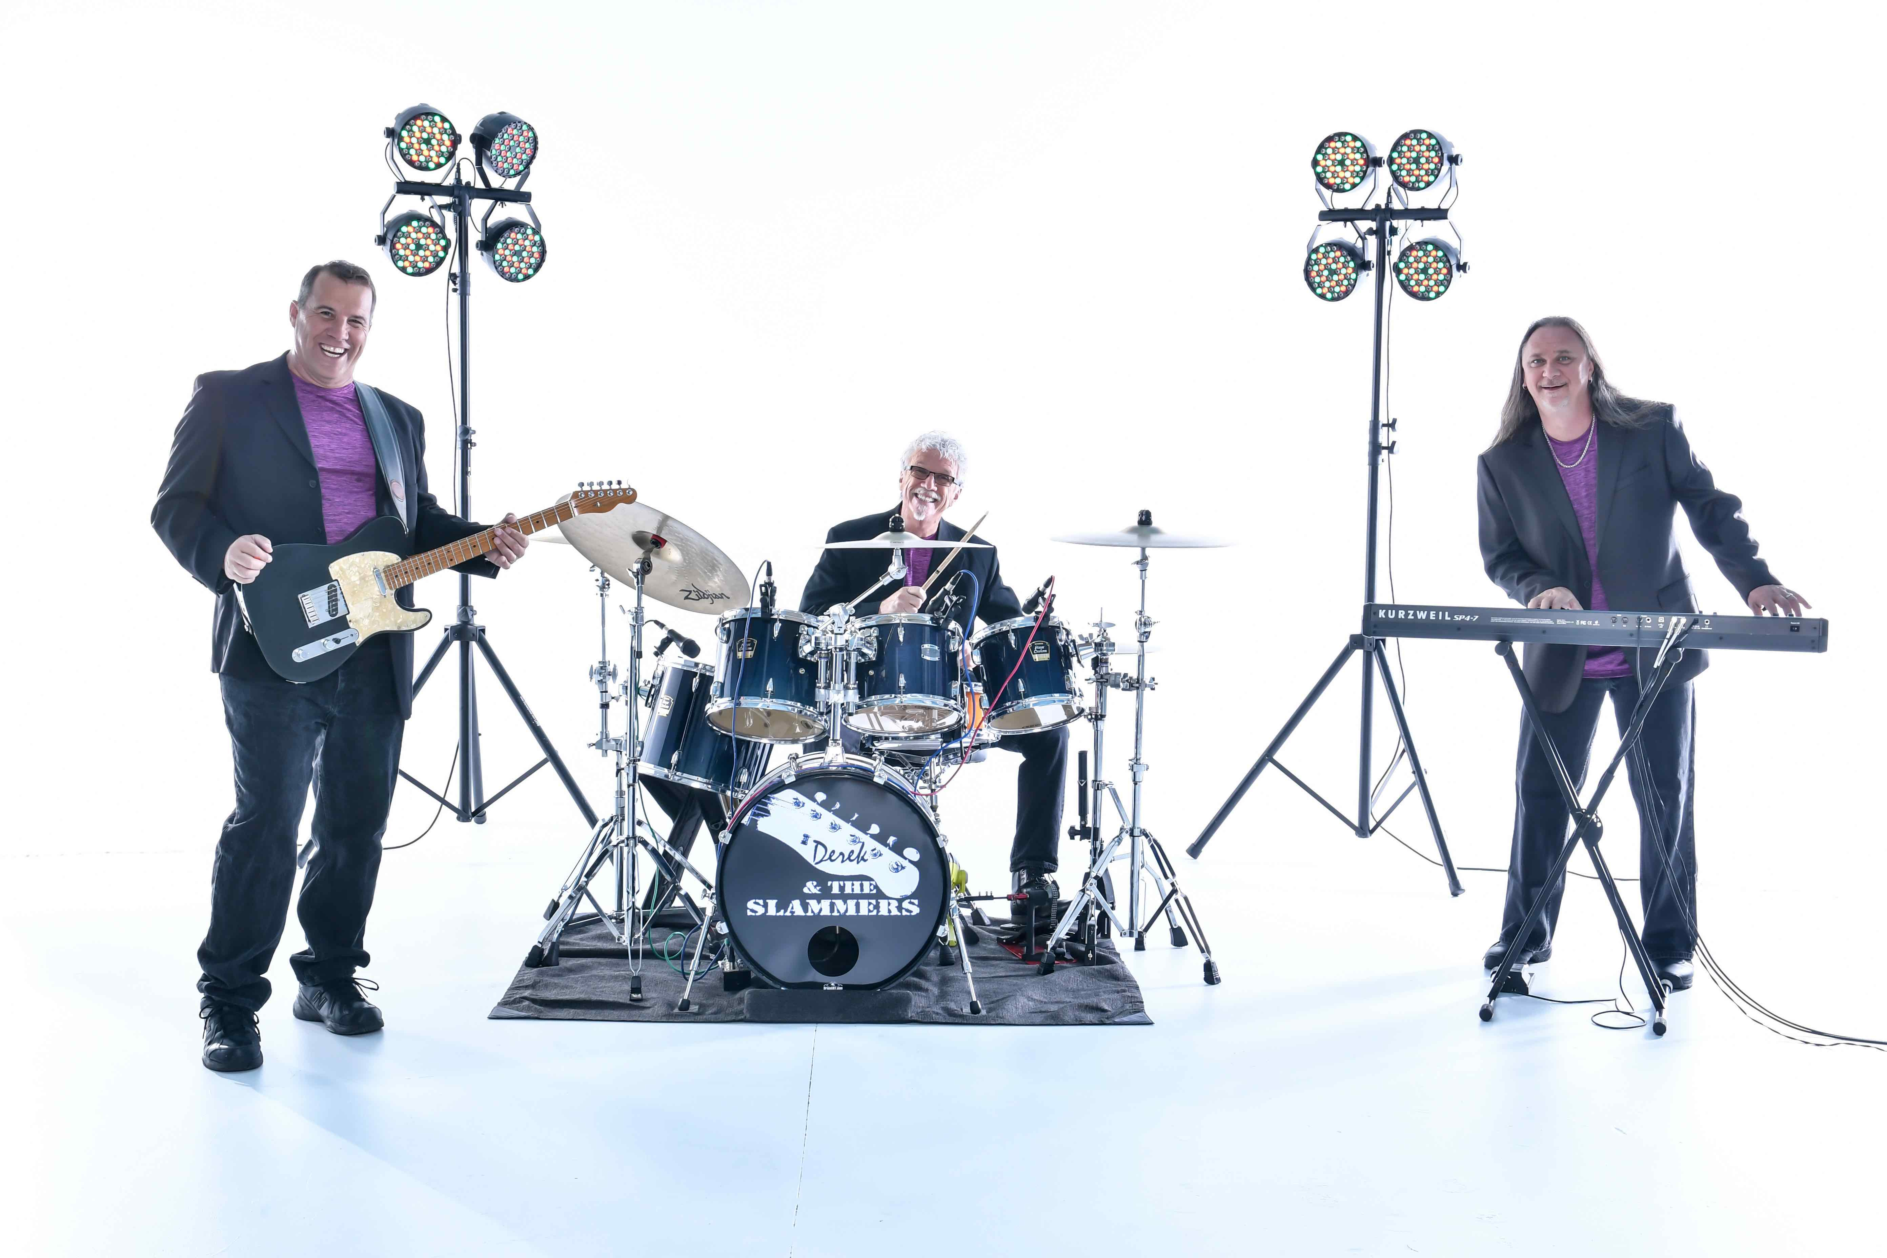
Derek's 3-piece band sounds like a full 8 pc band as this amazing trio produces big sound!

The bigger your party gets, the bigger the band can get! The 4 pc band option includes Guitar, Drums, Keys, and Sax. Add a Lead Singer/Bass player and you have the 5 pc option!

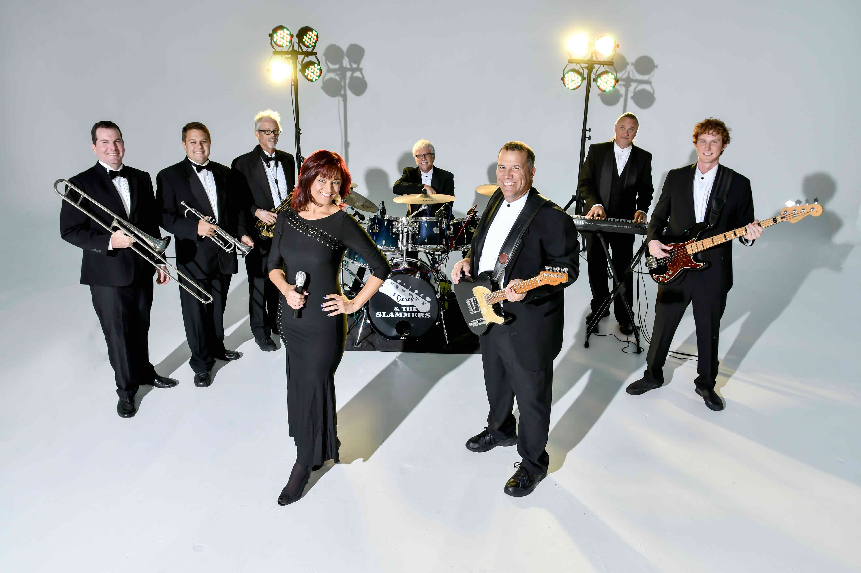
8 PC BAND:

It keeps getting better as we add a live horn section consisting of Trumpet, Sax, and Trombone, and fabulous male and female lead singers to create our big band option!

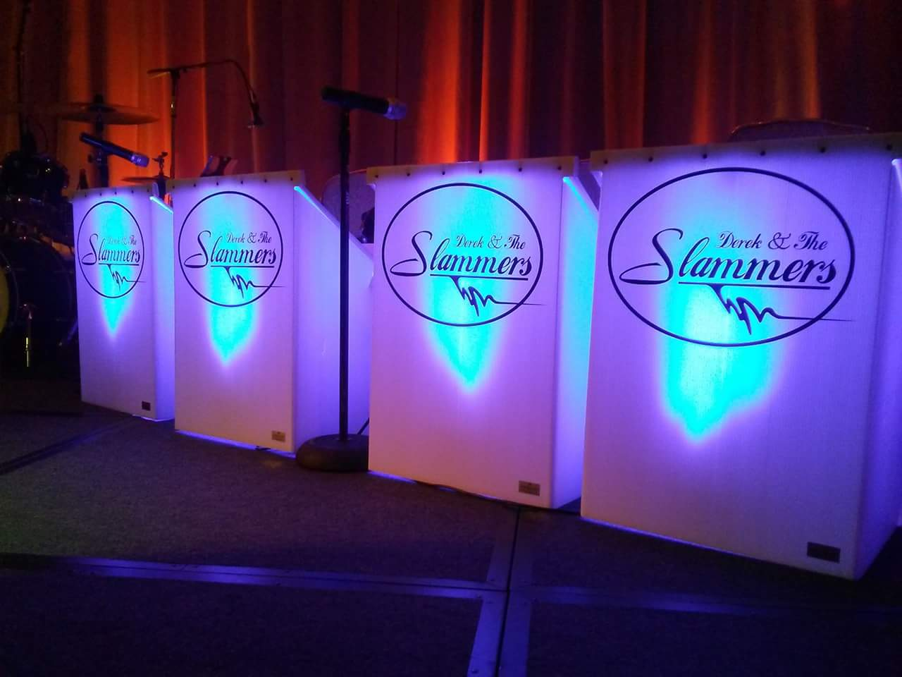
FORMAL:

Derek and the Slammers will bring their beautiful bandstands and perform dinner music! Later, they'll change into party attire and get the dance floor hoppin!

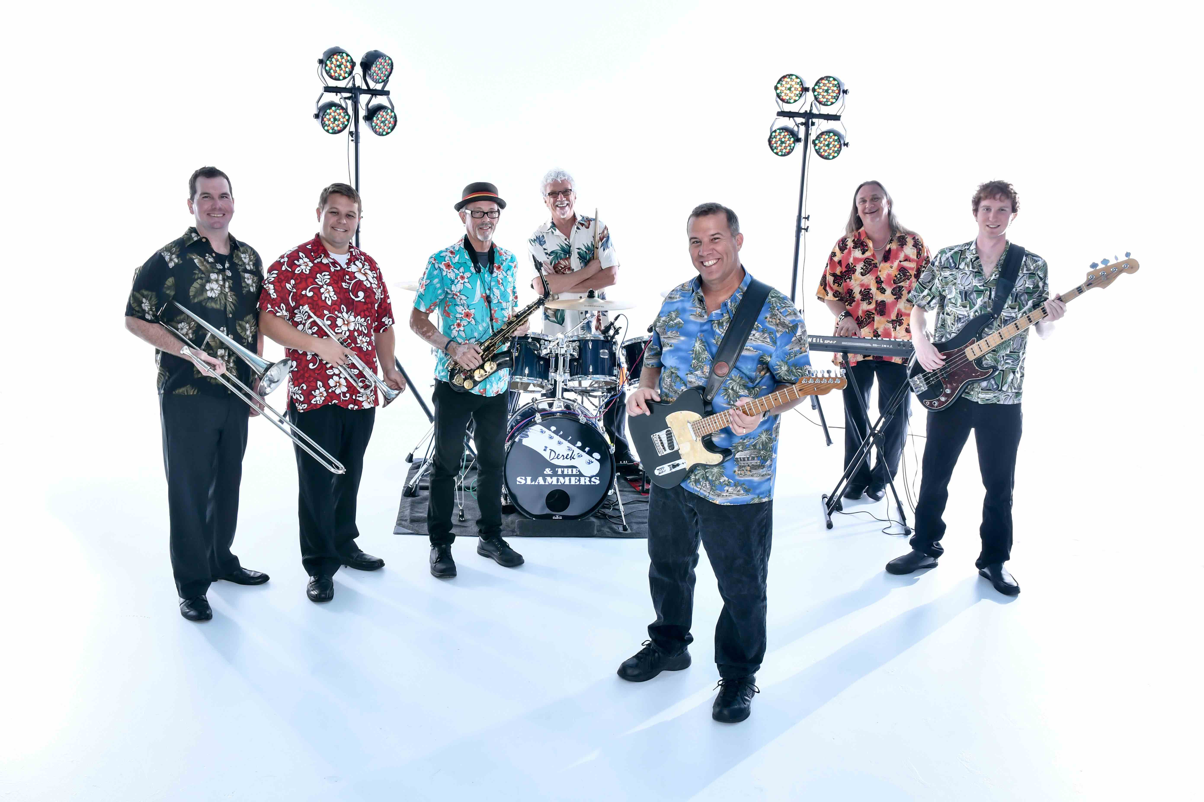

TROPICAL:

The sounds of Jimmy Buffett, Beach Boys, and more will take your guests to a tropical paradise!

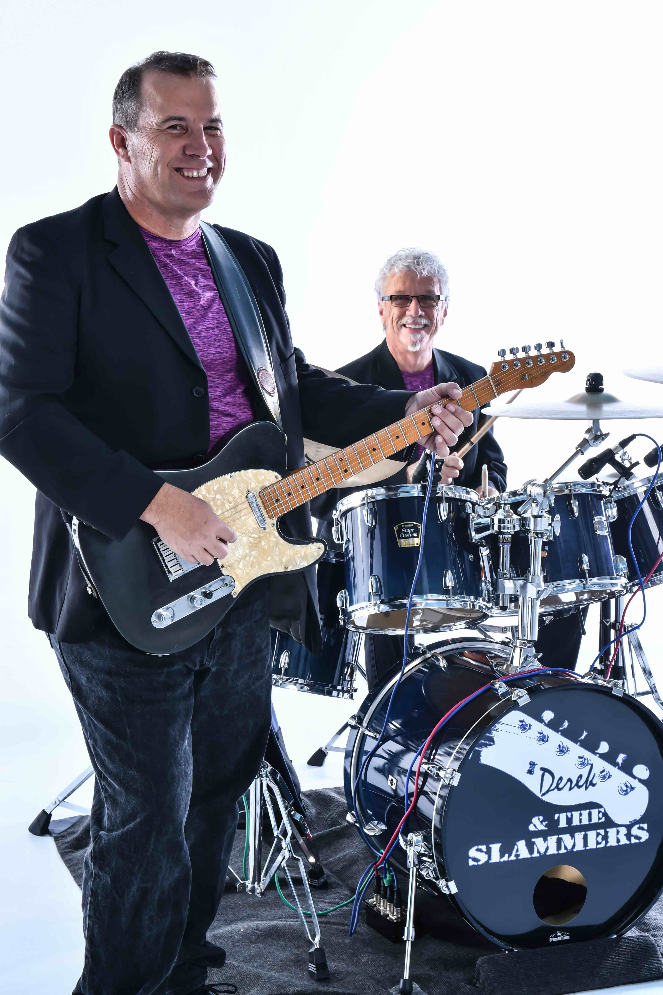
COCKAIL RECEPTION DUO:
You booked Derek and the Slammers for your event, but you need some musical ambience for your cocktail reception before doors open. Derek can set up a separate sound system and create a duo using his Drummer, Sax or Keyboard player.

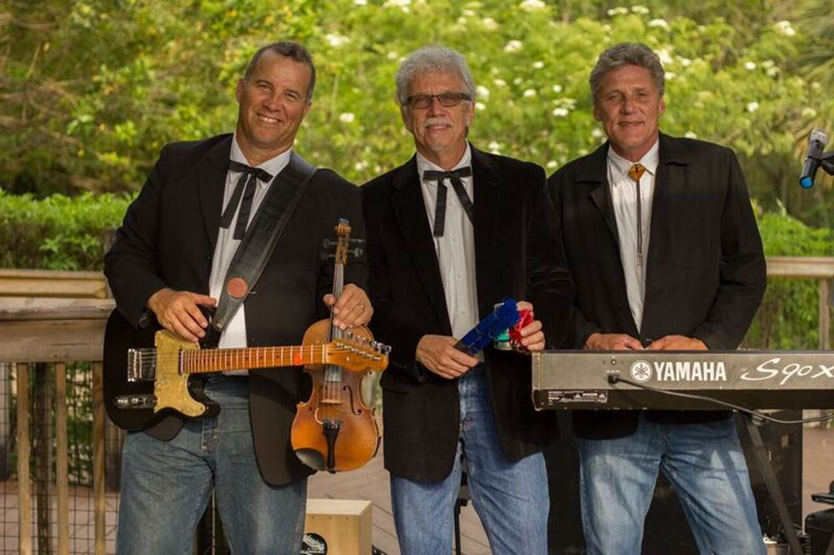
DEREK’S CAJUN BLUEGRASS:
Derek and the Slammers can give you a real toe tappin’ good time with their Bluegrass Trio. Great for backyard and country theme events, Derek will pull out the Fiddle, Banjo, and Mandolin for a good ol’ time!

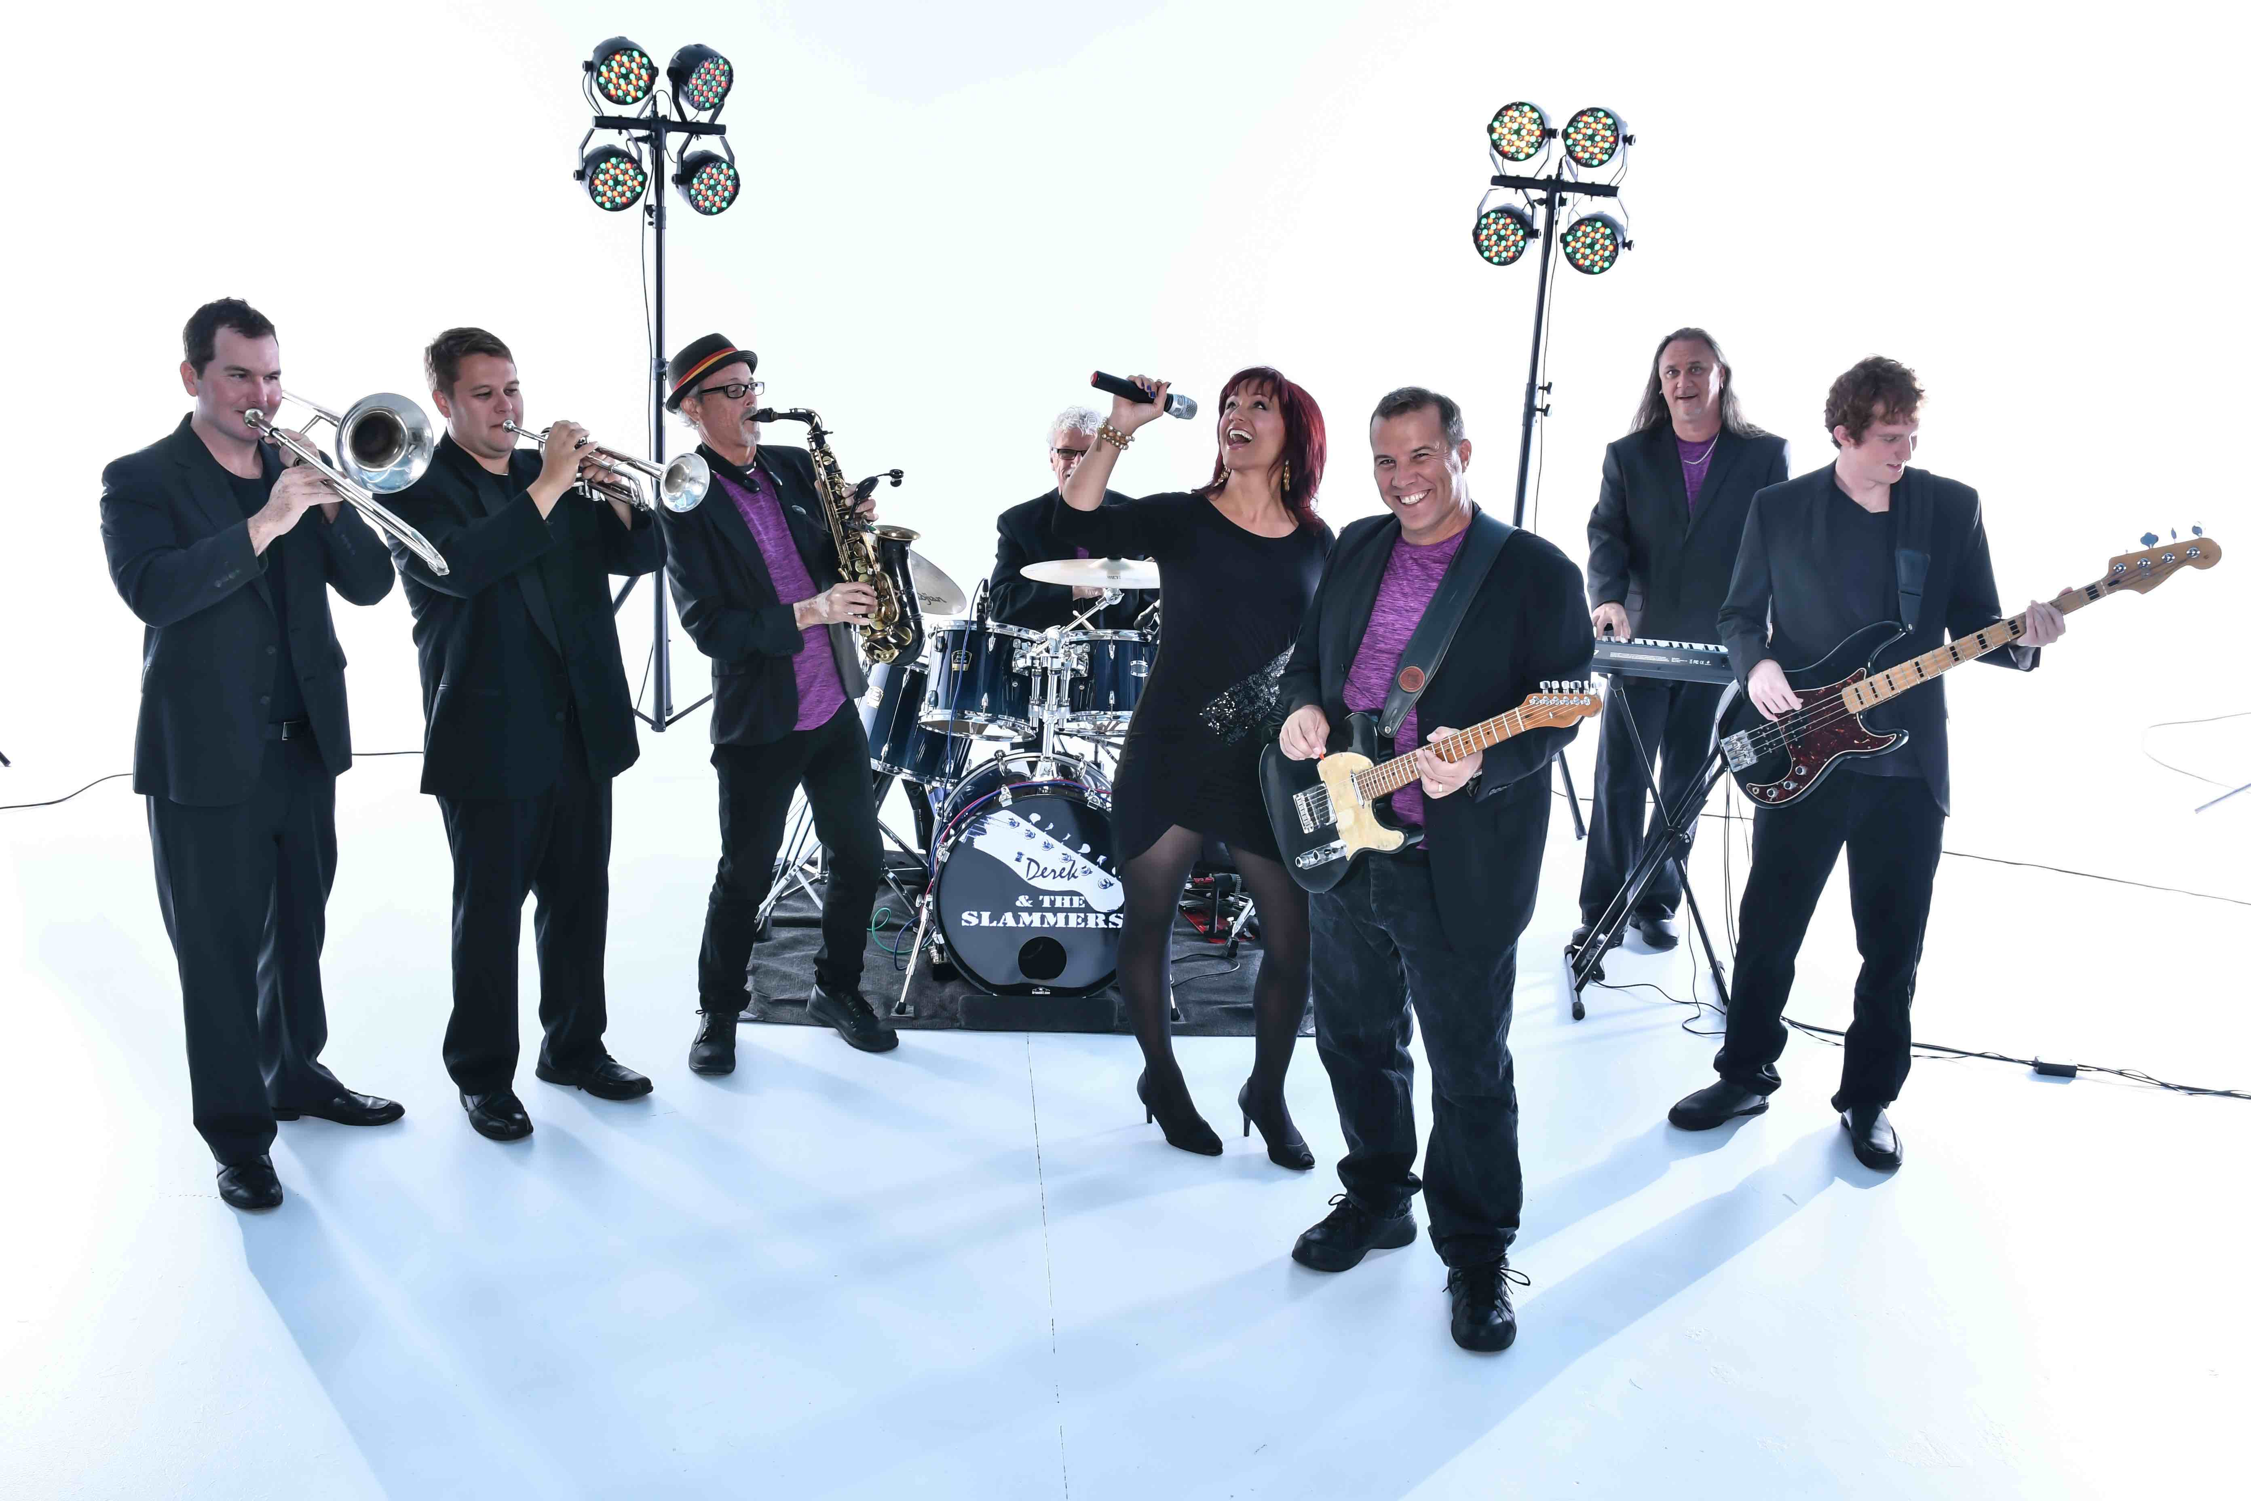
DEREK’S ROCKIN’ KARAOKE!
Now YOU can fulfill all of your childhood (or adulthood) dreams and sing with a live band! How many times have you sung your favorite song in front of a mirror holding your hair brush as a microphone! Now you can hop on stage and sing with live musicians! Just pick out your favorite song from their extensive list. A Host and Hostess will be there to help along as you sing the lyrics off the video monitor. This is 100% live with NO cheesy karaoke tracks!

